Core Concepts

1. Azure Virtual Network Basics
- A Virtual Network (VNet) is a logically isolated network within Azure, existing within a single subscription and region; it cannot span multiple subscriptions or regions. Lives within a Res. Group.
- VNets are composed of atleast one IP address spaces defined by CIDR blocks, usually IPv4 ranges (e.g., RFC1918 private ranges: 10.0.0.0/8, 172.16.0.0/12, 192.168.0.0/16). You can use non private IP ranges if you own a public IP space, but they will still be non-routable from the internet as they will be treated as private IP space in Azure for consistency and security. A single Azure Virtual Network (VNet) can have multiple IP ranges (address spaces) with different CIDRs, even mixing RFC1918 private ranges (like 10.x.x.x) and non-RFC1918 ranges (or even public ranges you own).
- VNets are subdivided into subnets, smaller segments of the IP range, each with a unique non-overlapping range. For each subnet you lose 5 addresses (n/w address 0 , broadcast 255, gateway 1, and 2/3 are reserved by azure to map to azure dns spaces. Smallest possible IP space is /29, giving 3 usable IPs. Subnets are regional and span availability zones; resources in different zones can belong to the same subnet. Vnet can’t be removed if there’s a subnet in it (even default) with or without resources, or NSGs exist, or Peerings exist, or Service endpoints exist.
- IPv6 support - Vnet is dual-stack (IPv4 + IPv6 only, not just ipv6); IPv6 subnets are always /64 in size. In IPv6, a /64 prefix means the first 64 bits are the network portion, and the remaining 64 bits are the host/interface identifier. This is the standard subnet size for almost all IPv6 networks. Azure enforces this because many IPv6 features require /64 to function correctly.
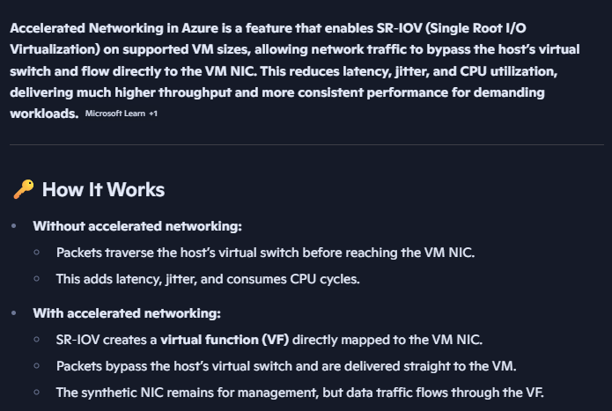
- Network Interface Cards (NICs) connect Azure resources (e.g., VMs) to subnets. Different NICs on same resource can connect to different subnet but must belong to the same Vnet. Single NIC can have multiple ipv4 addresses (same subnet only). For different subnet, new NIC is needed. Primary IP (the default source IP for outbound traffic and used by azure management/control plane, rdp/ssh) is always ipv4, and only 1 of the secondary IPs can be ipv6 – so ipv4 (1 primary and multiple secondary) and ipv6 (1 secondary). Secondary IPs are useful for hosting multiple services or binding multiple listeners on the same VM, as each additional IP will add more ports to which clients/services can connect to, and also helpful in NAT. IP can be set as static on the NIC. Public IP can be ipv4 or ipv6.
- Azure networking is software-defined, meaning no physical NICs or cables; all routing and security enforcement is virtualized.

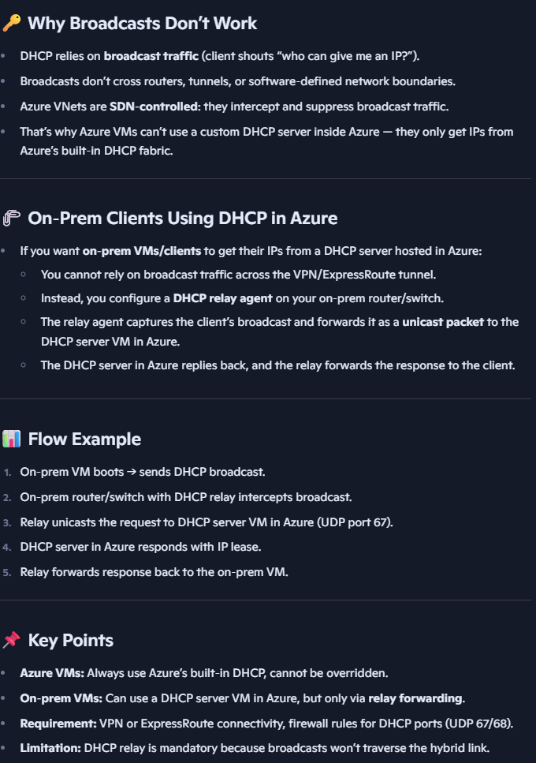
2. Traffic and Protocol Support
- Primarily supports Layer 3 IP traffic: IP based Layer 4 protocols TCP, UDP, ICMP (for diagnostics like ping), ESP/AH (IPsec).
- Does not support multicast, broadcast, promiscuous sniffer.
- Broadcast traffic (e.g., DHCP broadcasts) is intercepted by Azure S/w define network; you cannot deploy your own DHCP server in Azure directly but can use DHCP relay configurations for on-premise clients.
- You can’t ping Azure gateway as it’s a s/w defined component, not a real gateway like on prem.
- Traditional Layer 2 VLANs not supported as Azure is Layer 3 – everything is s/w defined.
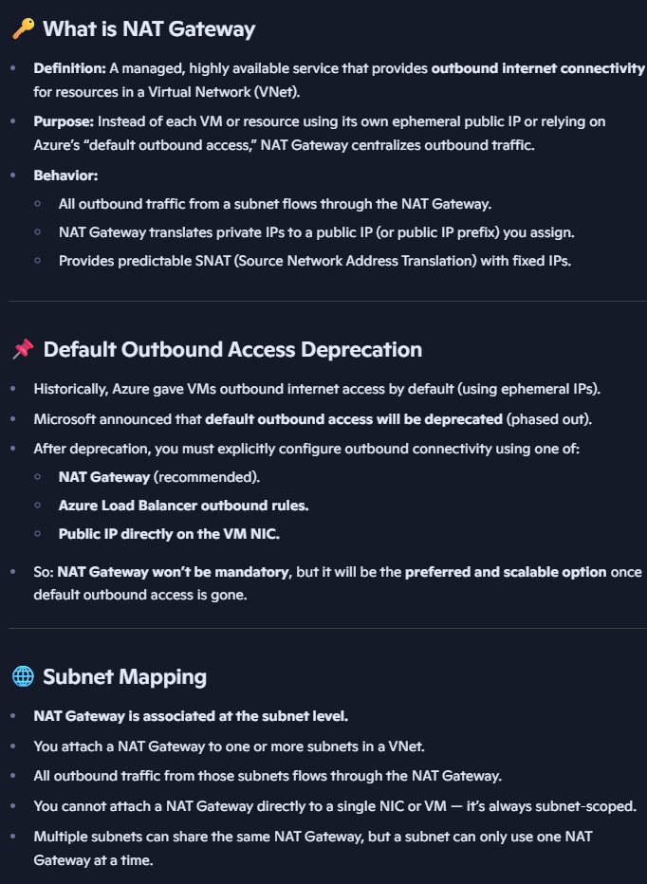

3. IP Addressing and NAT
- Azure uses dynamic IP address assignment via DHCP emulated by SDN but allows static IP reservations at the NIC level.
- Multiple IP configurations per NIC can be used to scale available ports for workloads.
- Public IP addresses are either IPv4 or IPv6 (not dual-stack) and are allocated from Microsoft-owned ranges . OR customers brought (BYO IP) specific portion of IP space (needs to be between /21 to /24 for ipv4) – it will get created as an azure address prefix which is a contiguous set of IPs – then broken into regional child ranges for regional services. Azure tells the internet to route to azure for those IPs.
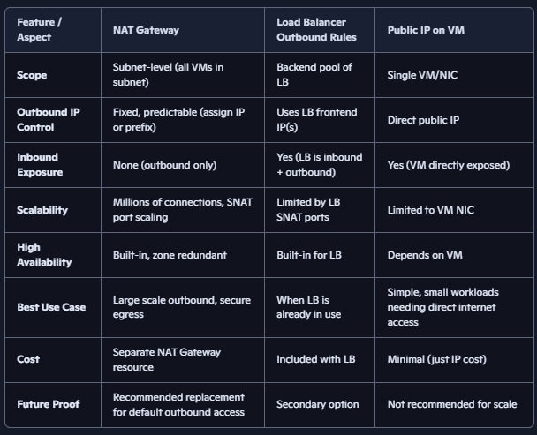
- Azure provides implicit internet access for VNets, which translates private IPs to public IPs using port address translation (PAT). This default outbound access behavior is being deprecated in favor of explicit outbound NAT solutions like NAT Gateway. NAT g/w can have upto 16 public IPs on it, each providing over 64k ports. NAT g/w is scoped to single vnet, but multiple subnets in vnet can use it. Can also use Load Balancer outbound rules - Useful if you already deploy a public load balancer for inbound traffic. Outbound traffic can reuse the same frontend IPs. Less scalable than NAT Gateway for heavy outbound workloads.
Or just use Public IP on VM: Simplest way to give a VM internet access. But exposes VM directly, not ideal for security. Limited scalability — each VM needs its own IP.

4. Connectivity Options
- Virtual Network Peering: Connects VNets (point to point via Microsoft backbone) within the same or different regions (regional and global peering), subscriptions and even tenants, to allow seamless IP communication using private IPs. Peering requires non-overlapping IP ranges. Peering is not transitive; each peering is point-to-point. If VNet A is peered with VNet B, and VNet B is peered with VNet C, A cannot automatically talk to C through B. Peering does not “chain” or “route transitively.” To connect A ↔ C, you must explicitly create a direct peering between them. One scenario when overlapped ranges are possible (but has many caveats): Have two separate peering chains -
Chain 1: Hub ↔ Spoke1 ↔ Spoke2 ; Chain 2: Hub ↔ Spoke3 ↔ Spoke4
Hub is not directly peered with Spoke2 or Spoke4. Spoke2 and Spoke4 can safely use overlapping IP ranges since they’re in different chains. Routes learned through one peering are not automatically propagated to another peering.
Peering incurs ingress and egress costs at both ends of the peered networks. Can peer entire VNets or specific subnets (subnet-level peering). Can also peer just ipv6.
- Hub-and-Spoke Architecture: Centralized hub Vnet hosting shared services (firewall, VPN gateway, DNS, NAT, etc.), with spoke vnets (Application or workload VNets) peered to the hub. Spokes do not communicate directly unless additional peerings or routing are configured. It offers centralized management of connectivity and security, Isolation of workloads in spokes, Simplified hybrid connectivity (hub connects to on-prem, spokes reach on-prem via hub).
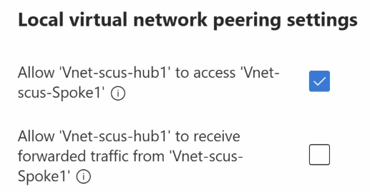
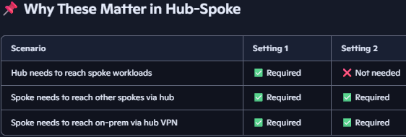
Setting 1: “Allow Vnet-scus-hub1 to access Vnet-scus-Spoke1” - Enables basic connectivity from the hub to the spoke. Hub resources (e.g., Azure Firewall, Route Server, VPN Gateway) can initiate traffic to spoke resources. Centralised services in the hub can reach workloads in the spoke. Setting 2: “Allow Vnet-scus-hub1 to receive forwarded traffic from Vnet-scus-Spoke1” - Allows forwarded traffic from the spoke to flow into the hub. Required if the spoke wants to route traffic through the hub, such as: Spoke1 → Hub Firewall → Spoke2 OR Spoke → Hub VPN Gateway → On-prem
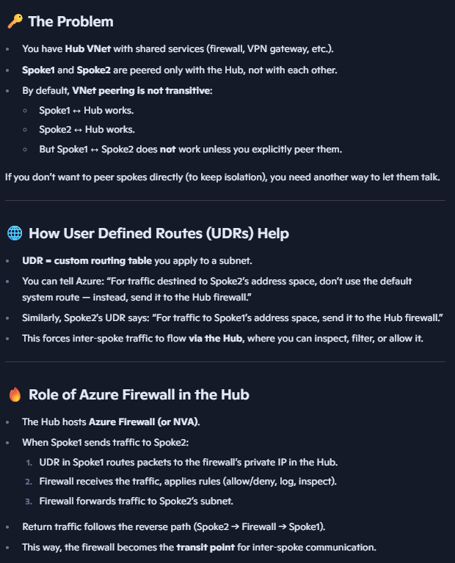
- User Defined Routes (UDRs): Custom routing rules that can redirect subnet traffic to firewalls or network virtual appliances. Can be added from Azure portal -> Route tables. Helps solve the problem when two spokes connected to a hub want to talk to each other, but there are not directly peered to each other. So each spoke can route the traffic to the private IP of a firewall in Hub, which then forwards it the other spoke.
- Azure Firewall and Network Virtual Appliances (NVAs): Provide centralized traffic inspection and filtering. Azure Firewall supports Layer 4 (protocol/port filtering) and Layer 7 TLS inspection.
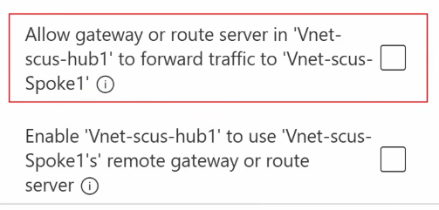
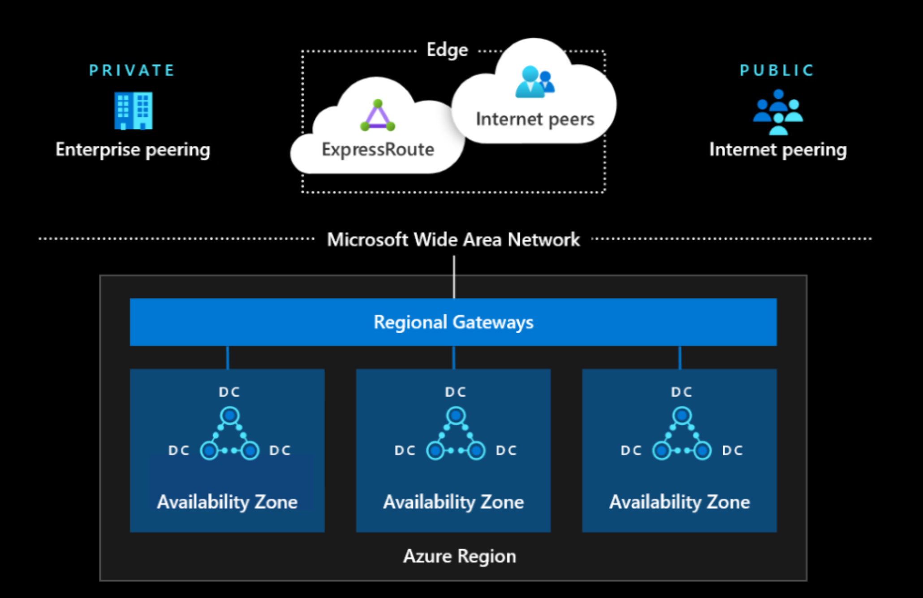
- Additional peering settings: “Allow gateway or route server in hub to forward traffic to spoke” - Enables gateway transit: hub’s gateway can forward traffic to spoke. “Enable hub to use spoke’s remote gateway or route server” - Rarely used; allows hub to use gateway in spoke.
These two VNet peering settings enable spokes to use the hub’s VPN Gateway or Route Server for external connectivity. This allows centralized routing to on-prem or other VNets without direct peering. Azure Route Server supports dynamic BGP-based routing (learn and exchange routes and plumb into the vnets), while VPN Gateway handles encrypted tunnels. UDRs with Azure Firewall/NVA offer custom routing and inspection but require manual configuration and don’t support dynamic route propagation.
Connecting On Prem to Azure: Enables hybrid cloud architectures, centralized identity, secure data migration, and disaster recovery.
Azure Network Architecture Components:
- Edge Network: Entry point for internet and ExpressRoute traffic.
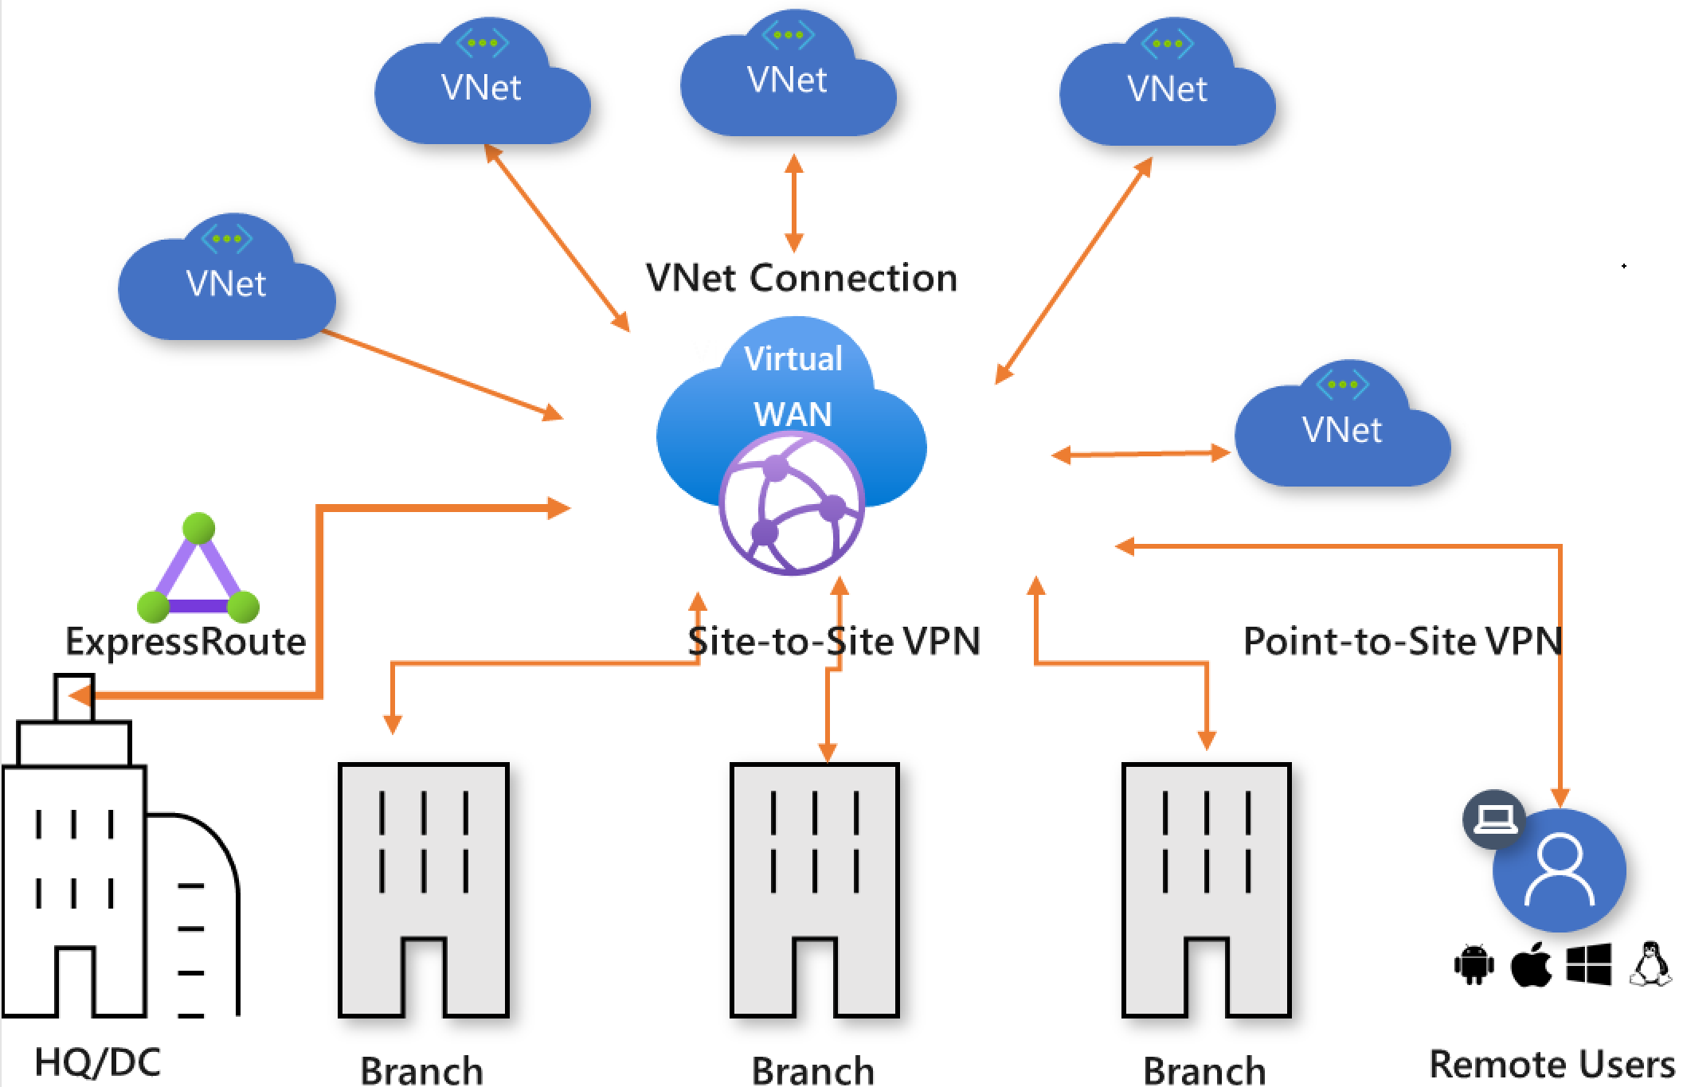
- Points of Presence (PoPs): Global peering hubs where Azure connects with ISPs and carriers. (Also used by Microsoft for Content Delivery network.)
- Wide Area Network (WAN): Microsoft’s private backbone connecting all Azure regions.
- Regional n/w Gateways: Aggregation points for traffic entering/exiting a region.
Datacenter Fabric: High-speed internal network connecting compute, storage, and services.
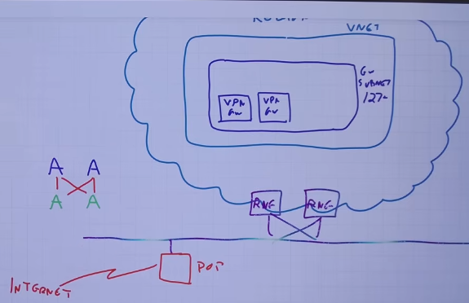
- Traffic Flow: User traffic enters via PoP or Express Route. Routed through Microsoft WAN to regional gateway. Delivered to target VNet or service.
P2S VPN – Open VPN (TLS 443, All clients), SSTP (TLS443, Windows), IKEV2(MAC)
Site-to-Site VPN:
Components:
Gateway Subnet – Dedicated subnet in Azure VNet for hosting VPN Gateway. Recommended /27, minimum /29
VPN g/w Types (SKUs) – Route-based (Uses routing tables; supports BGP, multiple tunnels, dynamic routing, express route and P2S can also be used); Policy-based (1 tunnel, Uses static IPsec policies; Express route can’t coexist)
Active-Active Gateways: Two VPN instances in g/w subnet, for HA and load balancing.
Traffic Flow: On-prem VPN device initiates IPsec tunnel to Azure VPN Gateway. Azure routes traffic to VNet via gateway subnet. Return traffic flows back through the same tunnel. 1Gbps per tunnel.
ExpressRoute (Circuit): Private, high-throughput connection between on-premises networks and Azure VNets via Microsoft’s global backbone n/w. Bypasses public internet using MPLS or Ethernet.
  - You order it through a connectivity provider (MPLS, Ethernet, or cloud exchange).
  - Capacity: Offered in bandwidth tiers (50 Mbps → 100 Gbps). Full Duplex so 100Gbps each direction.
  - Redundancy: Each circuit is provisioned with dual connections for high availability.
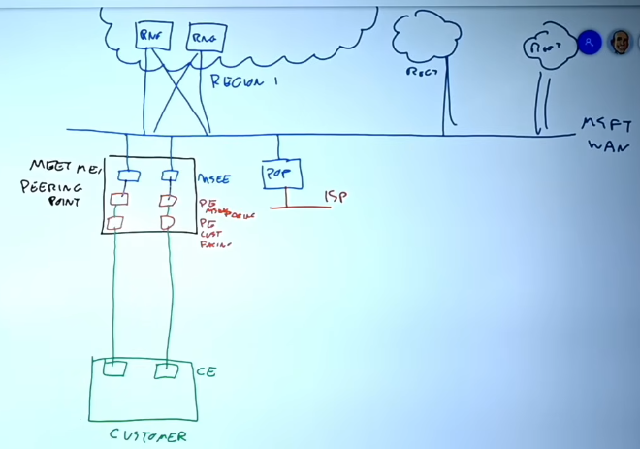
  - Scope: A circuit is the “pipe”, inside it you configure different peerings to reach things and advertise routes. Within a circuit, you can enable different peering types depending on what you want to reach:
Private Peering - Connects your on-premises network directly to Azure Vnets. Traffic: Private IP traffic (RFC1918) flows securely over the circuit. Use Case: Hybrid workloads — e.g., extending your datacenter into Azure Vnets. Routing: BGP exchanges routes between your routers and Microsoft’s edge routers.
Microsoft Peering - Purpose: Connects your on-premises network to Microsoft’s public services (Azure PaaS, Microsoft 365, Dynamics, etc.). Traffic: Public IP traffic (but delivered over the private circuit). Use Case: Access SaaS/PaaS securely without traversing the public internet. Routing: Create “Route Filter” for service, BGP advertises Microsoft public prefixes to your router.
  - Peering Point - The physical location where ISP provider connects customer network edge routers (green) to Microsoft’s enterprise edge routers (blue). Provider has both MS edge and customer edge facing routers (red), Usually a carrier hotel or internet exchange where Microsoft has a Point of Presence (PoP). Your circuit terminates here, and from this point traffic enters Microsoft’s global backbone. Choosing the right peering point affects latency and redundancy.
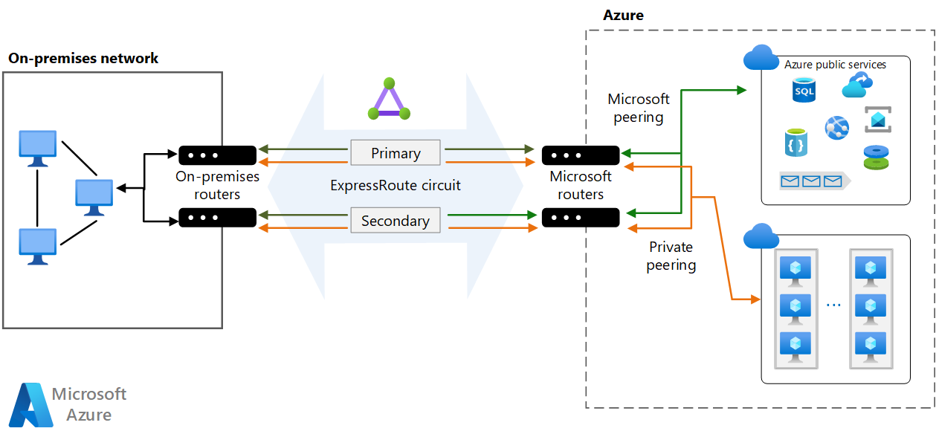
  - ExpressRoute Gateway - A special Azure resource (deployed in a Gateway Subnet) that connects your VNet to an ExpressRoute circuit. Acts as the “bridge” between your private VNet and the ExpressRoute circuit. Works with BGP to advertise VNet prefixes to your on-prem router via the circuit.
ADVANCED EXPRESS ROUTE FEATURES:
Resilient ExpressRoute - Circuits are provisioned with dual redundant connections at each peering location. Ensures high availability — if one link fails, traffic automatically fails over to the other.
SLA (99.95%–99.99%) for hybrid connectivity.
Metro ExpressRoute - Provides dual connections in two separate facilities within the same metro area.
Protects against facility-level failures while keeping latency low (same city).
Local SKU - An ExpressRoute SKU where traffic stays within the same metro/region. Connectivity is limited to Azure resources in that local region, and only gateways in that region are used, so no egress charges. Cost-effective for workloads that don’t need global reach. Cannot access Azure services outside the local region.
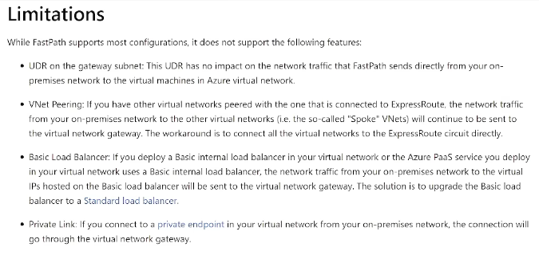
Global Reach - Feature that allows connecting two on-premises sites via Microsoft’s backbone using ExpressRoute. Site A ↔ ExpressRoute ↔ Azure backbone ↔ ExpressRoute ↔ Site B. Azure backbone acts as the private WAN between your datacenters. Eliminates need for separate MPLS WAN; leverages Microsoft’s global network.
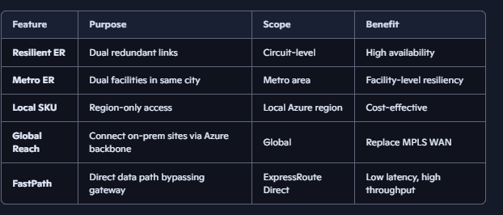
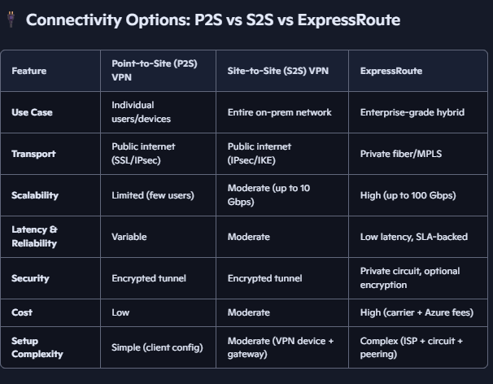
FastPath - A feature of ExpressRoute Direct that bypasses the ExpressRoute Gateway (in g/w subnet) for data path (but g/w is still used for BGP sessions for learning and exchanging routes). This only affects inbound traffic to azure, as outbound traffic anyways does not go through the gateway. Improves performance by sending traffic directly from your on-prem router into the Azure VNet, skipping gateway processing. Lower latency, higher throughput. Only available with ExpressRoute Direct (dedicated 10–100 Gbps ports). High-performance workloads (large data transfers, HPC, storage replication).
Express Route Direct does not have Provider routers in the circuit architecture, and only has Customer edge and MS edge routers in the peering point. Dual redundant ports at 10 Gbps or 100 Gbps each, supporting active-active traffic. Provides physical separation from other tenants, useful for regulated industries (banking, government, retail). MACsec is used for layer 2 encryption for connection b/w MS and customer router.

5. Security and Traffic Control – By default traffic can flow freely within a vnet and to any connected n/w.
- Network Security Groups (NSGs): Stateful firewall rules applied at subnet (recommended) or NIC level to allow or deny traffic based on source/destination IPs, ports, and protocols. NSG is enforced at host virtual switch level, so adding it from both subnet and NIC level doesn’t add double layer of protection, just complicates as they are both enforced together. If there is a conflict rule (allow traffic from subnet, deny same traffic from NIC), deny rule wins (most restrictive wins). NSG must be in same region+subscription as vnet where it is used. NSGs have some default rules (in below screenshot) which allow outbound to internet, and anything in Virtual network (which is all known Ip space including this vnet, peered vnets, express route etc),and deny all other outbound. Default inbound rules like anything from Vnets can talk to each other, but the allow rule for internet is missing, which means anything from internet is blocked by default, as denyallinbound exists for “any” – with highest number priority (so lowest priority). NSGs are stateful, so if we allow outbound to something like internet, we can get response back for that session. NSG tracks the session state (source/destination IP, port, protocol) and permits the reverse flow if the outbound was allowed.
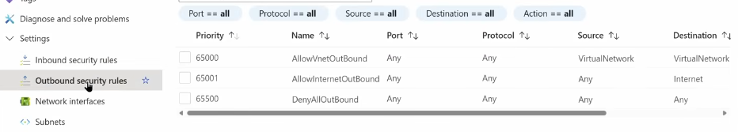
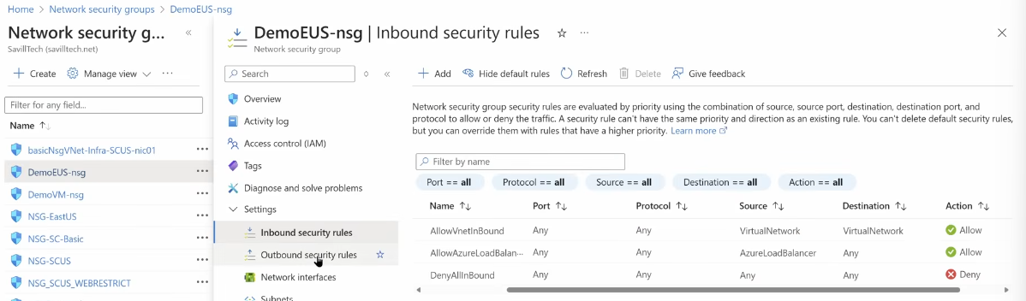
- Service Tags: Predefined groups of IP addresses representing Azure services for simplified NSG rule management, maintained by MS. Example in above NSG rules screenshot we have “VirtualNetwork”.
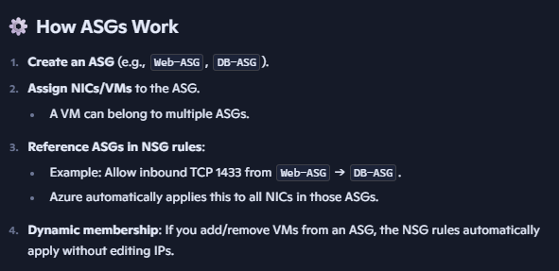
- Application Security Groups (ASGs): Logical groupings (tags) of NICs (or VMs) for simplified management of NSG rules. Instead of writing NSG rules against IP addresses or subnets, you reference the ASG name. Azure dynamically resolves the ASG to the NICs/VMs that are members of it. This makes NSG rules application-centric rather than IP-centric.
- Azure Firewall (or NVA): Managed, scalable security appliance supporting deep packet inspection, TLS inspection, and intrusion detection/prevention.
- Just-In-Time (JIT) Access: Temporarily allows inbound RDP/SSH by modifying NSGs dynamically.
Recommendations emphasize avoiding direct exposure of management ports (RDP/SSH) to the internet, using Defender JIT and Bastion hosts for secure access.

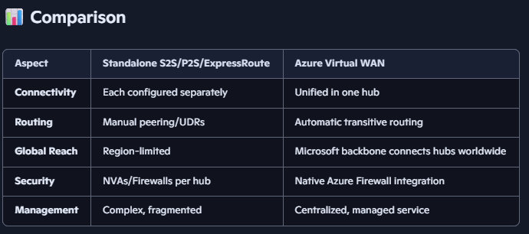
Azure Virtual WAN: Provides a managed hub which acts as a central point for connectivity. It allows enterprises to connect branch offices, remote users, on-premises datacenters, and Azure VNets through Microsoft’s backbone, simplifying hybrid and multi-cloud networking. It’s a managed networking service that unifies all the connectivity options (S2S, P2S, ExpressRoute) into a single, centralized architecture, with automation and global reach built in, and adds transitive routing between VNets and sites — something plain peering or standalone gateways don’t do. Adds Centralized routing, monitoring, Azure Firewall integration, and encryption for private connectivity. Each region within the vWAN instance gets a hub and traffic between hubs flows over Microsoft’s private WAN (backbone), ensuring low latency and high reliability. Two SKUs – Basic (S2s VPN Only) and Standard (S2S VPN, P2S VPN, ExpressRooute, inter-hub, Vnet transitive and more). Can use custom routes to restrict connectivity b/w connected vnets.
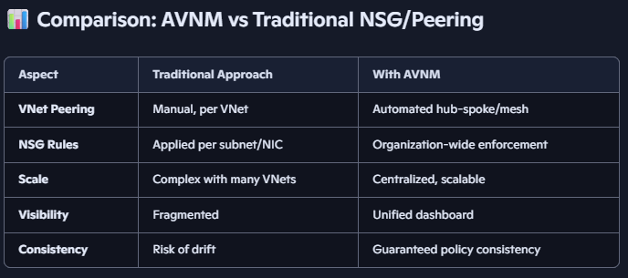
Azure Virtual Network Manager: A centralized service that lets you group, configure, and enforce policies across multiple VNets, subscriptions, regions and tenants. It simplifies managing complex topologies (hub-and-spoke, mesh) and security rules at scale, reducing manual overhead.
Define Network Groups - logical groups of VNets (e.g., all production VNets, all dev Vnets).
Create Configurations - Connectivity configuration (hub-and-spoke or mesh), Security configuration (NSG rules to allow/deny traffic; security admin rules which run before NSGs and has few extra things).
Deploy Configurations - Apply to selected VNets or groups. Roll out globally or regionally.
Monitor & Update - Centralized visibility into applied rules and connectivity. Update once, propagate everywhere.

6. Service Integration: Service Endpoints and Private Link
- Service Endpoints: Extend VNet identity to Azure PaaS services, enabling storage service’s firewall rules to restrict access to specific Vnets/subnets. Every Azure Storage Account is exposed via a public IP address (behind a DNS name like mystorage.blob.core.windows.net). That public IP is owned by Microsoft and reachable globally. When you enable a service endpoint on a subnet, traffic from that subnet to the Storage Account is forced onto the MS backbone network (enhanced routing) instead of traversing the public internet. Storage firewall can then allow traffic only from that subnet in vnet. It doesn’t prevent data exfiltration like service endpoint policies; only restricts network-level access. Added either from subnet level (add service endpoint), or from storage account level (add subnet).
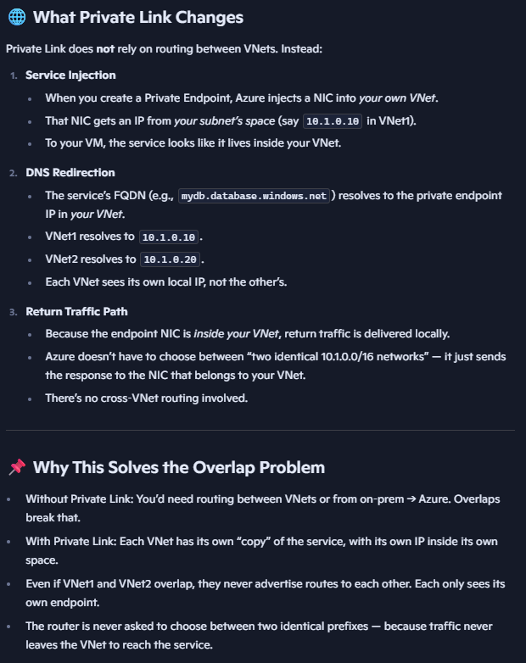
- Service Endpoint Policies: Allow granular control over which specific service instances a subnet can reach. Example: in case of storage service, prevent data exfiltration by restricting service endpoints to specific storage accounts. Filters are applied to service endpoint traffic. Policy restricts which specific Storage Accounts can be accessed. So Subnet can reach Storage, but policy allows only storageacct1 and blocks storageacct2.
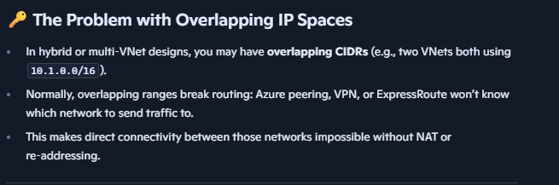
- Private Link: Provides a private IP address within the VNet to access an Azure PaaS service instance, completely eliminating exposure to the public internet. Uses private endpoints in subnets. As its instance specific it protects against data exfiltration by limiting access to specific service instances. Supports cross-VNet, on-premises access, and overlapping IP spaces without peering. It requires DNS configuration to resolve service FQDNs to private IPs via Azure Private DNS Zones. In Azure portal if we select “Integrate with private DNS zone”, Azure will automatically: Create the appropriate Private DNS Zone (e.g., privatelink.blob.core.windows.net). Add an A record mapping the service FQDN → private IP of the endpoint. Link the DNS zone to the VNet where the endpoint resides. If you skip this option, you must create the zone and records manually.
Private Link Service lets you publish your own service (for example, a custom application running behind a load balancer in Azure) and make it accessible privately to consumers in other VNets or even other tenants. Consumers connect to your service using a Private Endpoint in their own Vnet. The traffic flows entirely over the Azure backbone, never traversing the public internet.
Private Endpoint = consume a Microsoft service privately (e.g., Storage, SQL).
Private Link Service = expose your own service privately to others.

7. DNS in Azure
Public DNS Zones - Azure-hosted DNS zones that are globally resolvable over the public internet. Host DNS records for your public-facing services. Managed through Azure DNS, with high availability and low latency.
Private DNS Zones - DNS zones that are only resolvable inside linked Vnets. Provide name resolution for private endpoints, internal services, or hybrid workloads. Example: Private DNS zone privatelink.blob.core.windows.net. A record → mystorage.blob.core.windows.net → private IP of a Private Endpoint. VMs in linked VNets resolve the storage account to its private IP.
Azure Private DNS Resolver - A managed DNS forwarding service that enables hybrid name resolution between Azure VNets and on-premises DNS servers. Solves the problem of DNS resolution across hybrid and multi-VNet environments. Lets on-prem DNS servers forward queries into Azure. Lets Azure VMs forward queries to on-prem DNS servers. No need to deploy custom DNS forwarder VMs. Fully managed, scalable, and integrated with Azure DNS zones. Supports cond. forwarding rules.
- Azure DNS supports alias records integrated with Azure resources to avoid dangling DNS entries.

Key Insights
- Azure VNets are isolated per subscription and region, requiring explicit peering or gateways to enable cross-VNet or cross-region communication.
- Software-defined networking (SDN) eliminates traditional physical constraints, enabling flexible IP and subnet management but disallowing certain Layer 2 protocols (broadcast, multicast).
- Virtual Network Peering is the preferred method for connecting VNets, offering high performance but with added cost and non-transitive connectivity.
- Hybrid connectivity with on-premises networks is enabled via VPN Gateways or ExpressRoute, with ExpressRoute providing higher throughput, lower latency, and more reliability.
- Traffic security is layered, with NSGs providing basic filtering, ASGs simplifying rule management, and Azure Firewall enabling advanced inspection.
- Service Endpoints and Private Link represent evolving models for securing access to Azure PaaS services, with Private Link being the more secure, future-proof approach.
- DNS management is critical for ensuring correct name resolution, especially when leveraging Private Link, requiring integration of private DNS zones and, optionally, DNS resolvers for hybrid environments.
- Azure Virtual Network Manager helps scale and automate network management, overcoming complexity in large environments.

Quantitative and Configuration Highlights
Feature/Concept | Details/Values
IP Address Ranges | RFC1918 private address spaces: 10.0.0.0/8, 172.16.0.0/12, 192.168.0.0/16
Reserved IPs per Subnet | 5 IPs reserved (network, broadcast, gateway, Azure DNS, etc.)
IPv6 Subnet Size | Always /64
Max Subnets per VNet | 3,000
Public IP Type | IPv4 or IPv6 (Exclusive, no dual-stack)
NAT Gateway Scale | Up to 16 public IP prefixes; supports 800 subnets linked
ExpressRoute Routes Supported | Standard: 4,000; Premium: 10,000
ExpressRoute Circuits per Gateway | Local: varies; Premium supports global connectivity
Azure Firewall SKUs | Basic (lower throughput), Standard, Premium (with TLS inspection)
NSG Default Rules | Allow VNet inbound/outbound, Allow Azure Load Balancer, Deny all others
Private DNS Zone Limits | Linked to up to 1,000 VNets; auto-registration to one zone

Key Terms
- VNet (Virtual Network): Isolated network within Azure tied to a region and subscription.
- Subnet: Divided segment of VNet’s IP range.
- NIC (Network Interface Card): Connects resources to subnets.
- NSG (Network Security Group): Firewall rules for traffic filtering.
- ASG (Application Security Group): Logical grouping/tagging of NICs for NSG rules.
- Service Endpoint: Enables secured access to Azure PaaS services from VNets.
- Private Link: Provides private IP access to Azure PaaS services.
- ExpressRoute: Dedicated private connection between on-premises and Azure.
- BGP (Border Gateway Protocol): Routing protocol used for route propagation.
- User Defined Route (UDR): Custom routing rules within VNets.
- Azure Firewall: Managed security appliance with deep inspection.
- Azure Private DNS Zone: Private DNS for name resolution inside VNets.
- Azure Virtual Network Manager: Centralized network management service.
- Fast Path: ExpressRoute feature to bypass gateways for performance.

